**MrMrsCart (Customer Module)**

**Functionalities**

1.Registration

2.Login

3.Add Store

4.Wishlist

5.Adding to Cart

6.Buy Product

7.My Profile

8.Bank Details

9.Change Password

10.Manage Payment

11.Address

12.Orders

13.Not Yet Shipped

14.Cancelled Orders

15.Payment Integration

16.Help and Support

17.Switch Account

18.Compare Products

1. Register and Login:

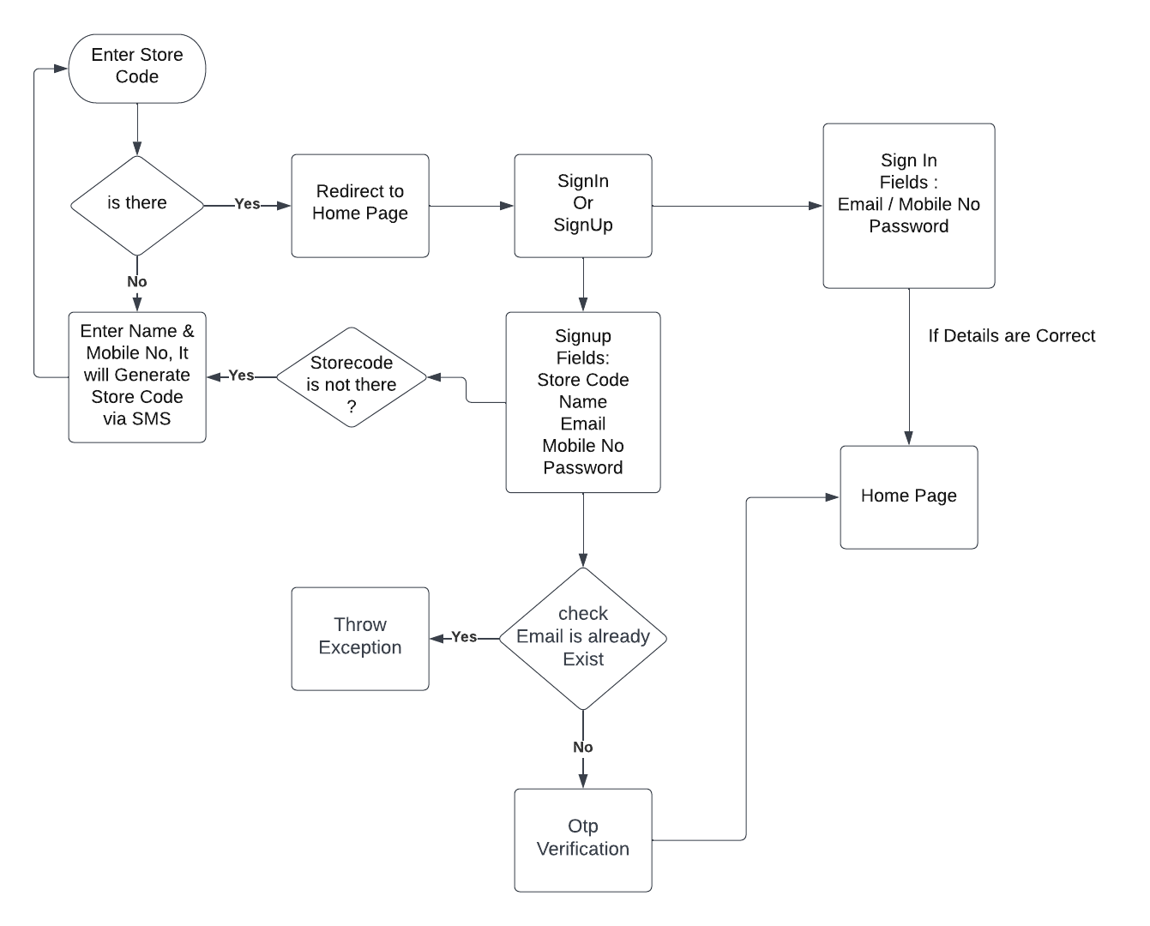

1. **Add Store:**

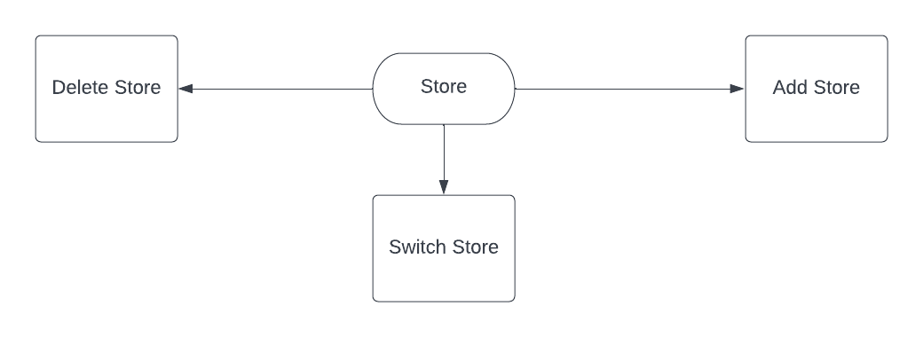

1. **Wish List:**

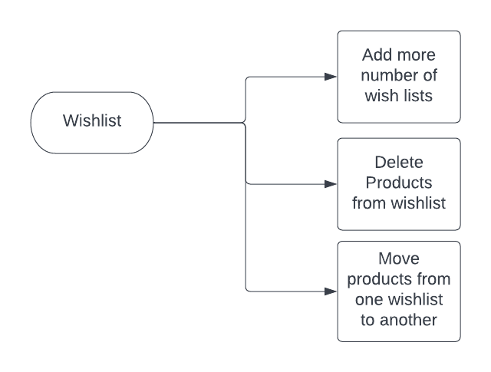

1. **ADD TO CART:**

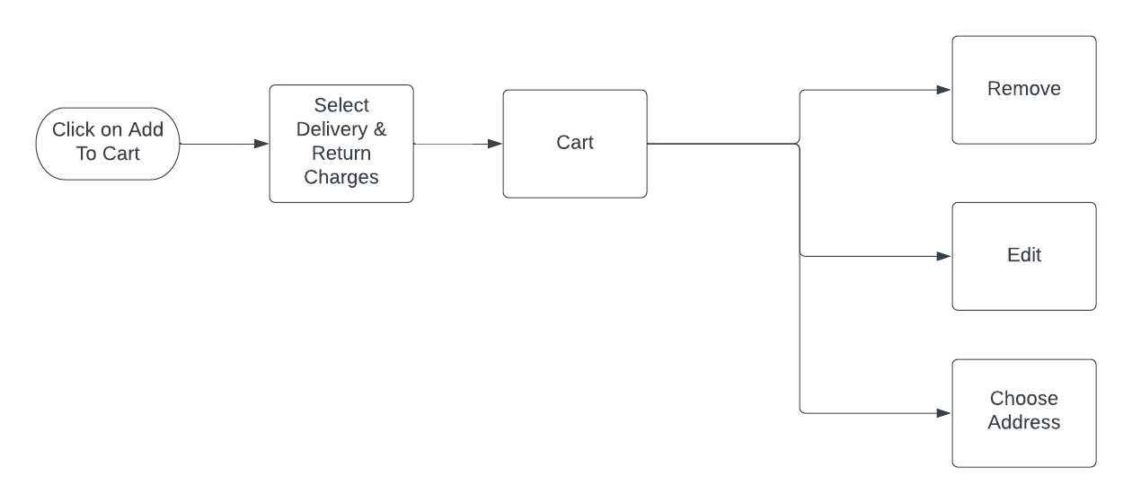

1. **Buy Product:**

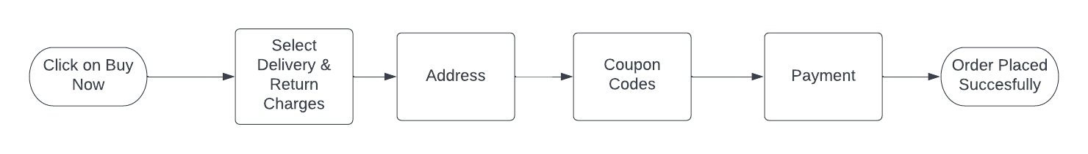

7.My Profile:

Description:

* Customer can update any of the below fields.

1. First Name.
2. Last Name.
3. Mobile Number.
4. Email Id.

* Verification has to be done on change of Email Id or Mobile Number.

Flow Chart:

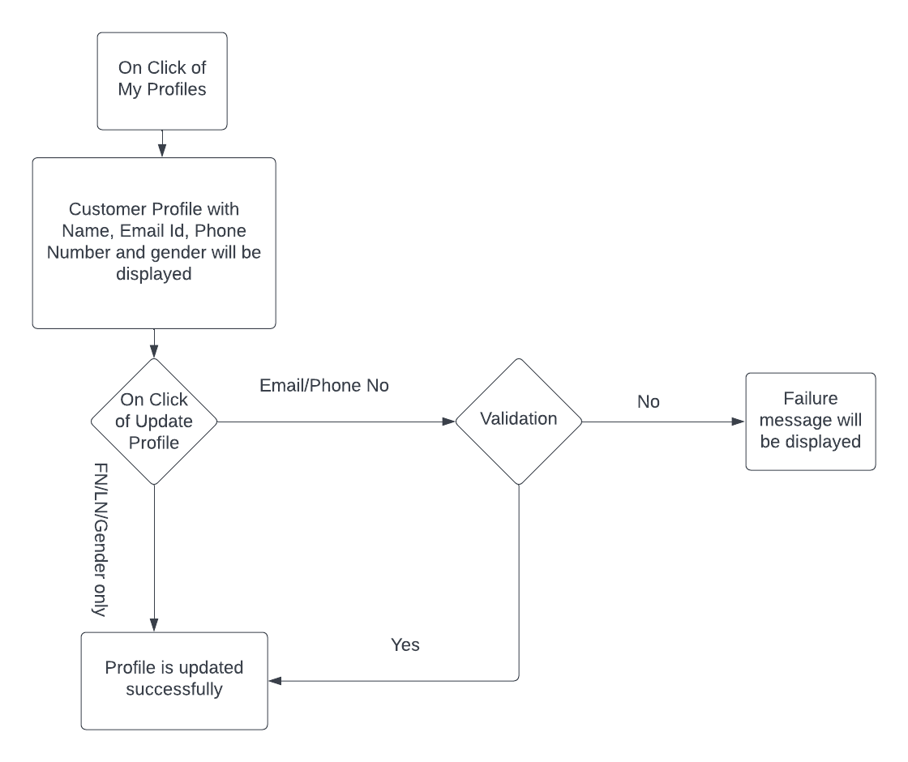

8.Bank Details:

Description:

* Customer can add multiple Bank Details.
* Previously added bank details will be displayed here.
* Customer can also add new bank details, by giving the below information.

1. Account Holder Name.
2. Account Number.
3. IFSC Code.

* Customer can also update or delete bank details.

Flow Chart:

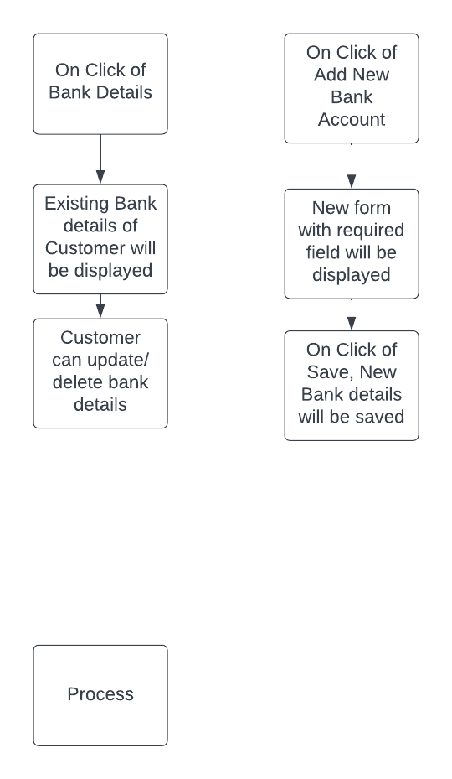

9.Change Password:

Description:

* Customer can change password by giving below information.

1. Email Id.
2. Old Password.
3. New Password.

* If old password and Email Id are correct, password will be changed or else failed message will be displayed.

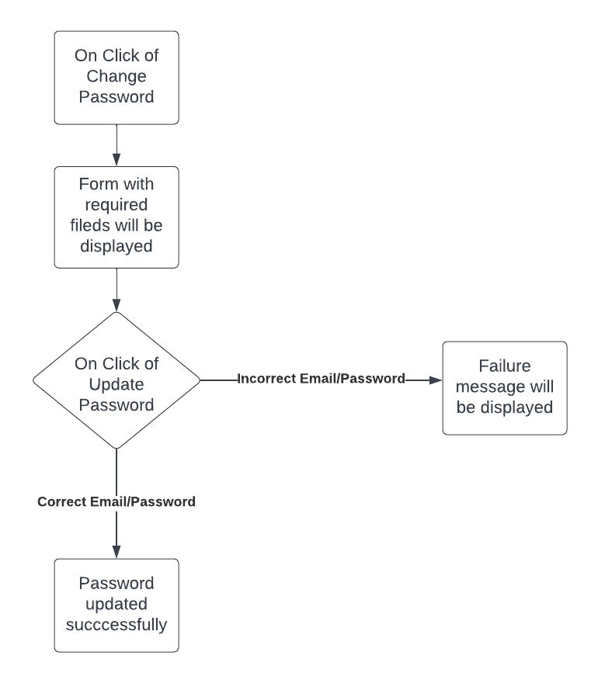Flow Chart:

10.Manage Payment:

Description:

* Customer can add multiple Debit/Credit cards.
* Previously added Debit/Credit card details will be displayed here.
* Customer can also add new Debit/Credit card details.

Note: UI/UX is not available after clicking on “Add new Debit/Credit card”

What should happen after selecting existing card details.?

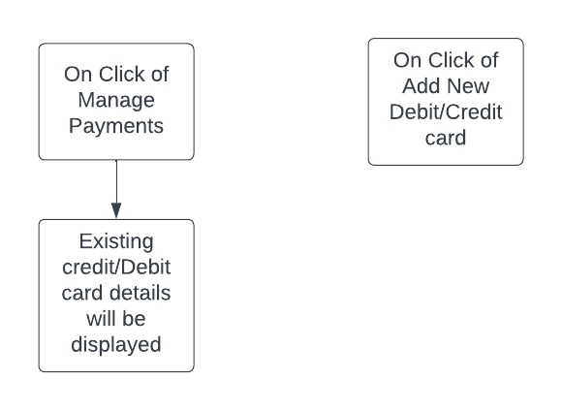Flow Chart:

11.Address:

Description:

* Customer can add multiple addresses.
* Previously added address details will be displayed here.
* Customer can update or delete the existing address details.
* Customer can also add new address details.

Flow Chart:

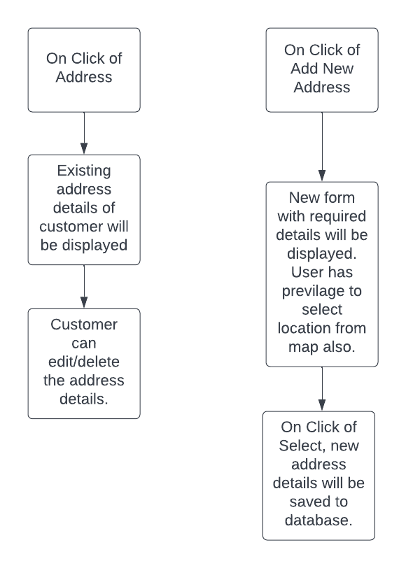

11.Orders:

Description:

Previously added orders will be displayed here.

Customer can perform below operations.

* Cancelling the orders.
* Returning the products.
* Viewing order details.
* Downloading invoice.
* Order tracking.
* Giving feedback to products and seller.

Note: What should happen when customer clicks on save for later.?

Flow Chart:

12. Help and Support:

Help and Support

Customer

Reseller

Supplier

Create Ticket

Message box

Reply

Notification

View

Ticket status

Display ticket-id, date, subject, status in tabular form

13. Comparing Products and Switch Account:

No

Yes

Switch between multiple existing accounts

Add account

If no multiple account

Switch Account

Remove all added products

Clear all

Yes

A view will be displayed with the details comparison of selected .pr

Start compare

Add Similar Product

15. Payment Integration:

Payment failure

Return order placed successfully with mailed and transaction id

Pop up

Payment Success

BharatPe

BHIM UPI

GPay

Internet Banking

Payment

17. Not Yet Shipped and Cancelled Orders:

Yes

Display the cancelled product

Yes

Display the product which is not yet shipped

Cancelled Orders

Not Yet shipped

Orders